ASSESSMENT TOOL 1 – APPLICATION BASED QUESTIONS

NAME :- Ch Rama Karthik REDDY
REG NO :- 192472281
COURSE CODE :- DSA0305
COURSE NAME :- NATURAL LANUGUAGE PROCESSING

1.Design and implement a Python-based resume information extraction system using Regular Expressions that performs the following tasks:

Extract the candidate's name.
Identify email addresses.
Extract mobile numbers.
Detect technical skills (Python, Java, SQL, Machine Learning, NLP).
Extract years of experience.
Generate a structured summary of the candidate's profile.
Display candidates who satisfy the minimum eligibility criteria (minimum 2 years of experience and Python skill).

import re

# Sample resumes
resumes = [
"""
Name: John Smith
Email: johnsmith@gmail.com
Mobile: 9876543210
Skills: Python, Java, SQL, Machine Learning
Experience: 3 years
""",

"""
Name: Priya Sharma
Email: priya@gmail.com
Phone: 9123456789
Skills: Java, SQL
Experience: 1 year
""",

"""
Name: Rahul Kumar
Email: rahul@yahoo.com
Mobile: 9988776655
Skills: Python, NLP, Machine Learning
Experience: 5 years
"""
]

skills_list = ["Python", "Java", "SQL", "Machine Learning", "NLP"]

print("========== Resume Information Extraction ==========\n")

for resume in resumes:

# Extract Name
name = re.search(r"Name:\s*(.*)", resume)
name = name.group(1) if name else "Not Found"

# Extract Email
email = re.search(r"[A-Za-z0-9._%+-]+@[A-Za-z0-9.-]+\.[A-Za-z]{2,}", resume)
email = email.group() if email else "Not Found"

# Extract Mobile Number
mobile = re.search(r"\b\d{10}\b", resume)
mobile = mobile.group() if mobile else "Not Found"

# Extract Skills
found_skills = []
for skill in skills_list:
if re.search(skill, resume, re.IGNORECASE):
found_skills.append(skill)

# Extract Experience
exp = re.search(r"(\d+)\s+year", resume, re.IGNORECASE)
experience = int(exp.group(1)) if exp else 0

# Structured Summary
print("Candidate Profile")
print("----------------------------")
print("Name :", name)
print("Email :", email)
print("Mobile :", mobile)
print("Skills :", ", ".join(found_skills))
print("Experience :", experience, "years")

# Eligibility Check
if experience >= 2 and "Python" in found_skills:
print("Status : Eligible")
else:
print("Status : Not Eligible")

print()

Output:
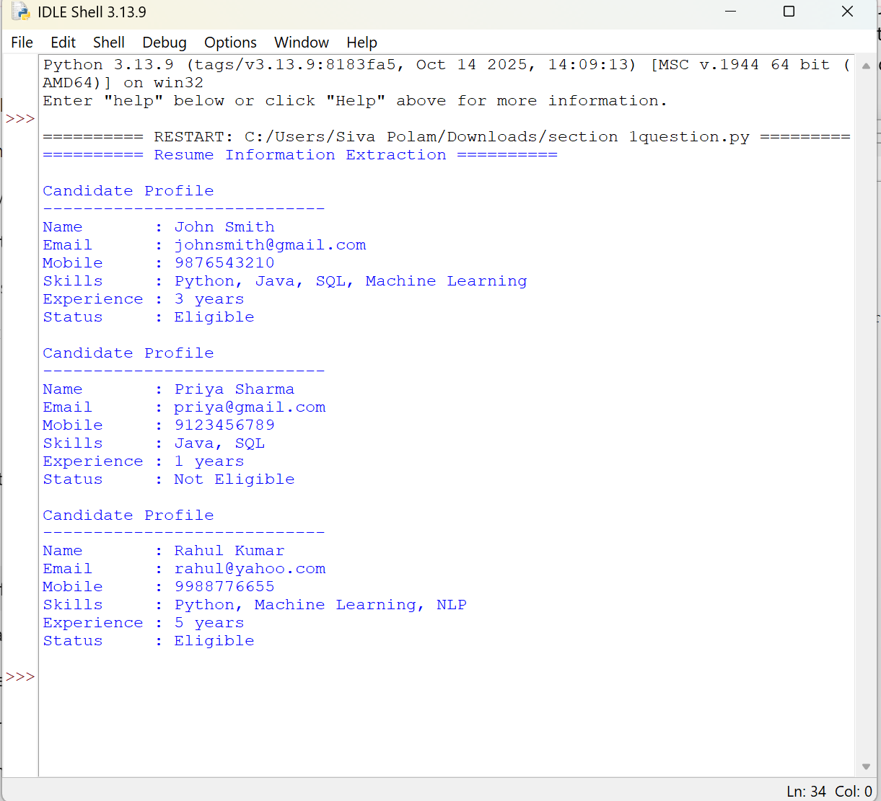

2.An e-commerce company plans to enhance its product search engine to improve customer experience through flexible keyword matching.

Design and implement a Python-based product search system using Regular Expressions that performs the following tasks:

Search products using an exact keyword.
Perform prefix-based searches.
Perform suffix-based searches.
Search using partial keywords.
Perform case-insensitive searches.
Display all matching product names.
Generate a report showing the total number of matching products for each search.

import re

# Product List
products = [
"Apple iPhone 15",
"Apple Watch",
"Samsung Galaxy S24",
"Sony Headphones",
"Dell Laptop",
"HP Laptop",
"Lenovo Laptop",
"Apple AirPods",
"Bluetooth Speaker",
"Wireless Mouse"
]

# Function for Product Search
def search_products(pattern, flag=0):
result = [p for p in products if re.search(pattern, p, flag)]
for p in result:
print(p)
print("Total Matching Products:", len(result))
print()

print("----- Exact Keyword Search (Laptop) -----")
search_products(r"\bLaptop\b")

print("----- Prefix Search (Apple) -----")
search_products(r"^Apple")

print("----- Suffix Search (Laptop) -----")
search_products(r"Laptop$")

print("----- Partial Keyword Search (Phone) -----")
search_products(r"Phone")

print("----- Case-Insensitive Search (apple) -----")
search_products(r"apple", re.IGNORECASE)

Output:
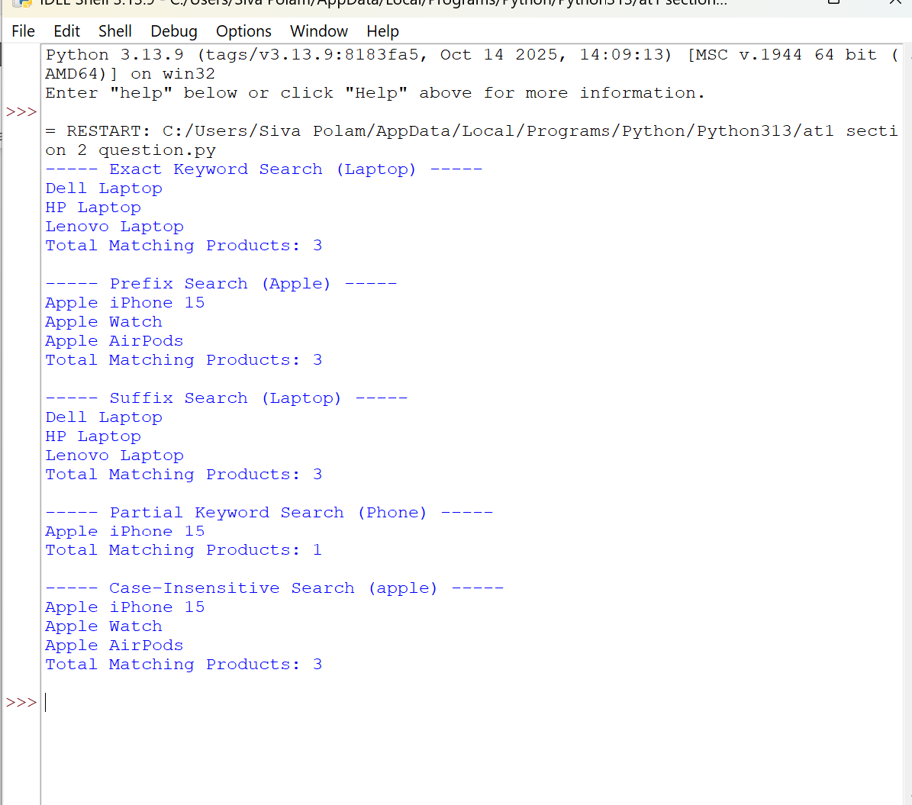

3.A university is developing an automated online registration portal to verify student information before course enrollment.

Design and implement a Python-based validation system using Regular Expressions that performs the following tasks:

Validate the student register number.
Validate the institutional email address.
Validate the course code.
Validate the semester information.
Validate the student's mobile number.
Display appropriate validation messages for each field.
Generate a final registration status report indicating whether the registration is successful.

import re

# Student Details
reg_no = "23CS001"
email = "student@saveetha.edu.in"
course = "CS301"
semester = "5"
mobile = "9876543210"

status = True

# Register Number
if re.fullmatch(r"\d{2}[A-Z]{2}\d{3}", reg_no):
print("Register Number : Valid")
else:
print("Register Number : Invalid")
status = False

# Institutional Email
if re.fullmatch(r"[a-zA-Z0-9._%+-]+@saveetha\.edu\.in", email):
print("Email : Valid")
else:
print("Email : Invalid")
status = False

# Course Code
if re.fullmatch(r"[A-Z]{2}\d{3}", course):
print("Course Code : Valid")
else:
print("Course Code : Invalid")
status = False

# Semester
if re.fullmatch(r"[1-8]", semester):
print("Semester : Valid")
else:
print("Semester : Invalid")
status = False

# Mobile Number
if re.fullmatch(r"[6-9]\d{9}", mobile):
print("Mobile Number : Valid")
else:
print("Mobile Number : Invalid")
status = False

# Final Registration Status
print("\nRegistration Status")
if status:
print("Registration Successful")
else:
print("Registration Failed")

Output:
